# CS 255 System Design Document Template

This template lays out all the different sections that you need to complete for Project Two. Each section has guidance to prompt your thinking. You will need to continually reference the interview transcript as you work to make sure that you are addressing your client’s needs. There is no required length for the final document. Instead the goal is to complete each section based on what your client’s needs are. Remove this note when you are finished, and replace all bracketed text with the relevant information.

## UML Diagrams

### UML Use Case Diagram

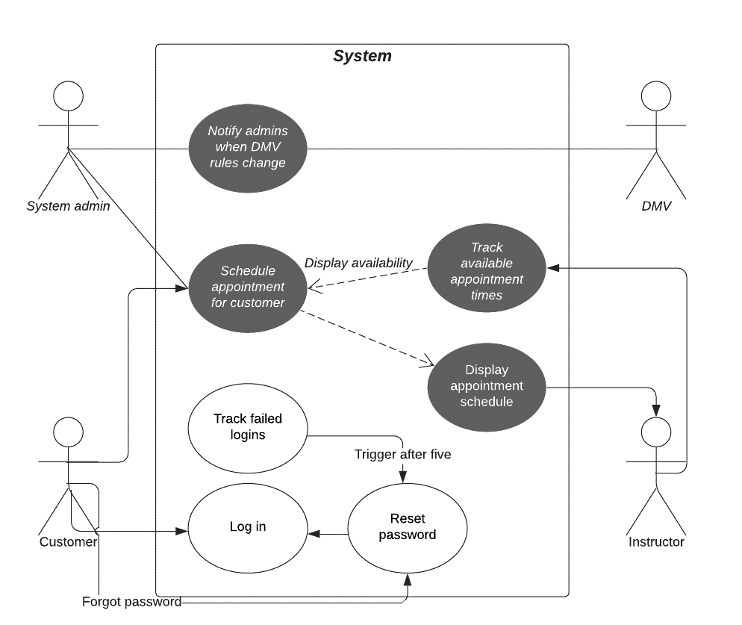

### UML Activity Diagrams

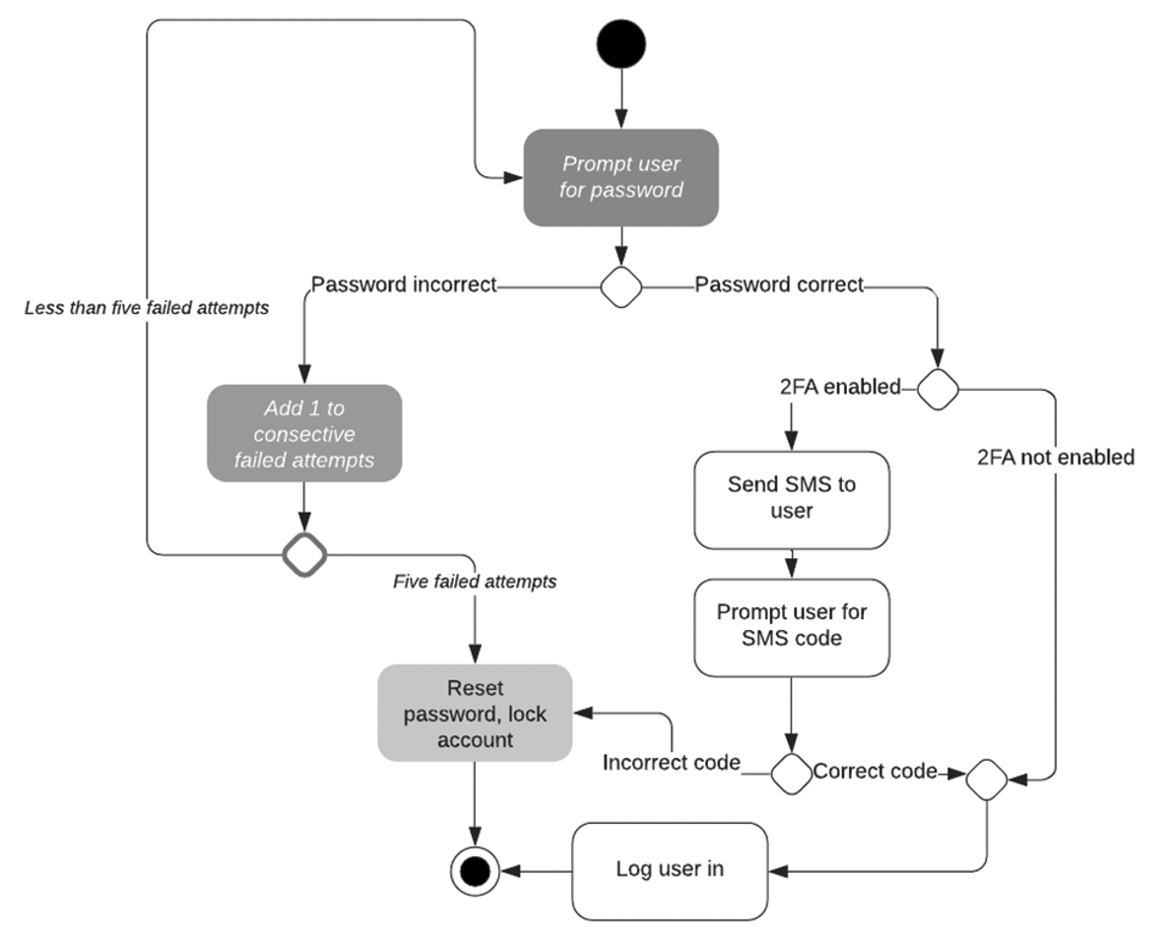

### 

### UML Sequence Diagram

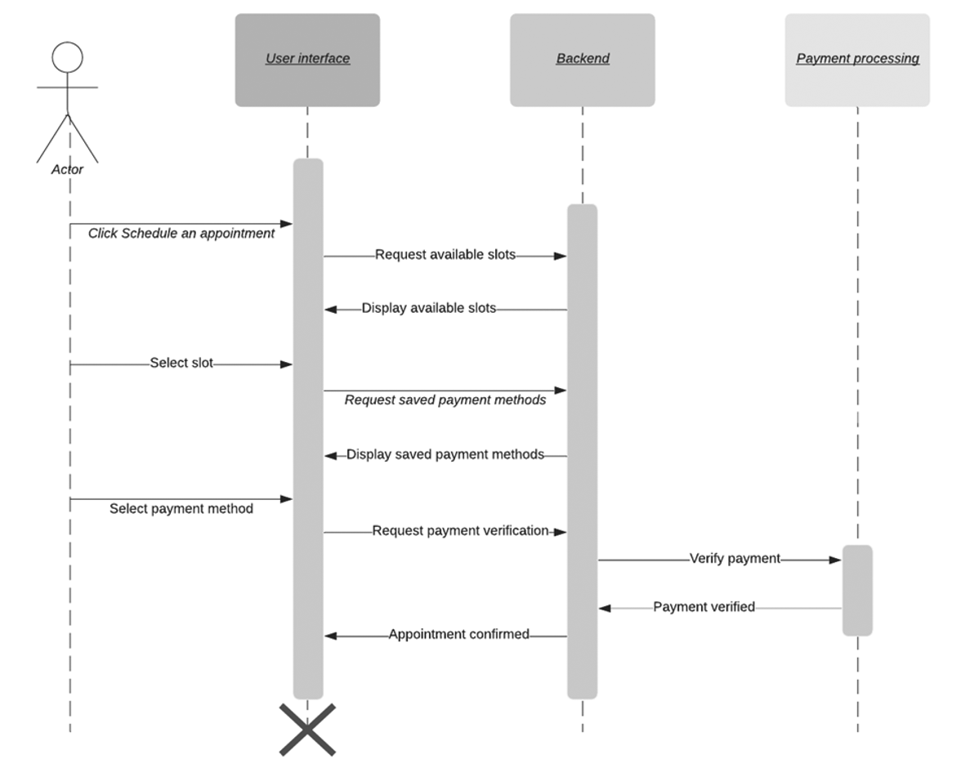

### UML Class Diagram

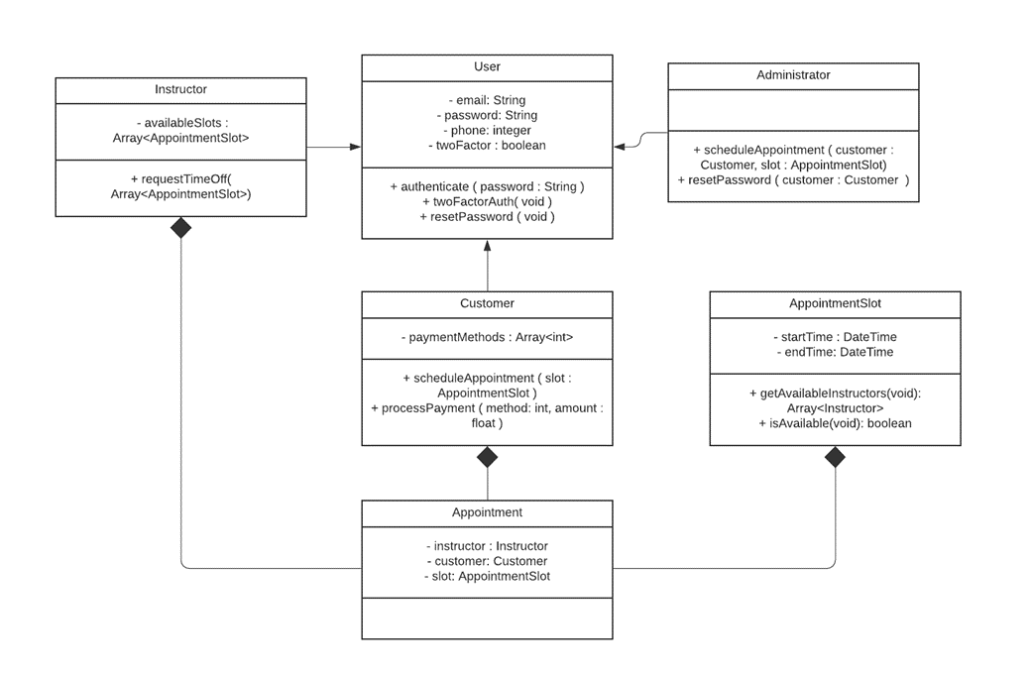

## Technical Requirements

Hardware Requirements:

Hosting:

* Needs a local server
* Needs full server set up with desktop computer, monitors, keyboard, and a mouse and a way to operate it
* Internet to provide support and operate the setup

Client operation:

* A device that can connect to the internet
* Internet to provide support to the device

Software Requirements:  
Hosting:

* A Linux compatible server operation system
* The fully developed software for the DriverPass application

Client operation:

* Fully up to date software for the intended device
* Browser version is most current

Infrastructure Requirements:

Hosting and Client operations:

* Cloud-based server hosting
* Local connection to a network to access the application
* Functioning DriverPass application